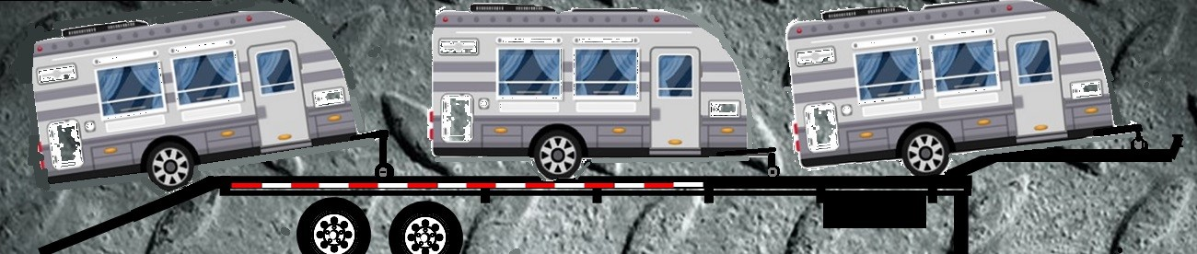
Model 8700 RV/Car Haul Trailers

The Model 8700 trailer is manufactured with a structural heavy duty steel frame, huck bolt fastened steel crossmembers, poonched steel tread loading deck and a fully enclosed steel center deck. The trailer weighs 9,100 lbs. and can be rated up to 32,000 GVWR and is an easy tow behind a 1-1/2 ton or better pickup truck or a semi tractor as dependent on the trailer rating.

Standard Features:
53’ x 102” RV Trailer Structural Steel Frame
4” Steel Channel Crossmember Supports
Huck Bolt Structural Fasteners Used On All Critical Joints
Steel Poonched Loading Deck and Rub-Rail
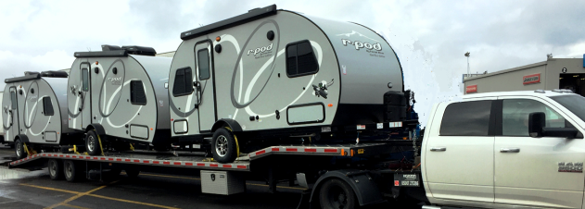
Fully Enclosed Steel Center Deck w/ Flush Center Rail
- 10,000 lb. Axles (26,000 GVWR)
235/75R17.5 - 16 Ply Radial Tires and Steel Wheels
235/75R17.5 - 16 Ply Radial Spare Tire w/ Carrier
Electric Over Hydraulic Disc Brake Controller Kit
Paint - Black Two Component Alkyd Topcoat Over Primer
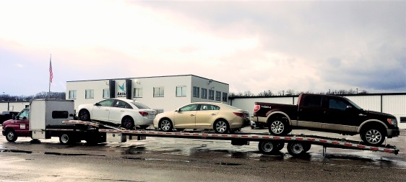
Front Track ‘Stinger’ Extension
Single Battery in Dedicated Aluminum Controls Box
Electric Planetary Gear Winch with Wireless Remote
- RV Electrical Receptacles Front, Mid and Rear Trailer
Seven Pin RV Tow Vehicle Connecting Plug w/ 6 ft. Wire Lead
Std. Two Pin Forklift Plug for Charging Electric Winch
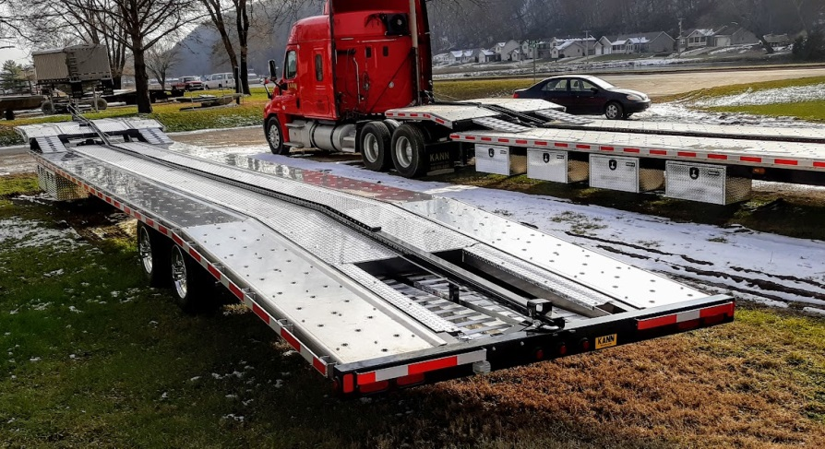
25,000 lb. Landing Gear
LED Lighting
34” Over Wheel Deck Height
(2) 48”x18”x18” Lockable Aluminum Toolboxes
- Set of Aluminum Front Jump Ramps
(1) Set of 10 ft. Aluminum Loading Ramps
(3) Ball Tower
(1) Wheel Tower
(12) Ratchet Straps with Double Deck Hook Ends
DOT Conspicuity Reflective Tape
DOT Inspection
1 Year Manufacturer’s Warranty

Optional Features:
Aluminum Poonched Decking
Aluminum Center Deck
Aluminum Wheels (each)
Additional Spare Tire & Carrier (each)
(2) 15,000 lb. Axles (32,000 GVWR)
(1) 20,000 lb. Dual Tire Air Ride Axle (26,000 GVWR)
(2) 20,000 lb. Dual Tire Air Ride Axle (36,000 GVWR)
Custom Paint Color (other than standard black)
Additional 48” Aluminum Toolbox (each)
Additional 48” Steel Toolbox (each)
Additional Battery in Toolbox
12 V 12,000 lb. Worm Drive Winch
LED Lights (each)
KANN Manufacturing Corporation
210 Regent Street
PO Box 400
Guttenberg, IA 52052
P. 800.806.5266 F. 563.252.3069
www.kannmfg.com www.facebook.com/kannmfg

For more information please contact:
Email: sales@kannmfg.com
Phone: 800-806-5266 ext. 211

